Loan Eligibility Documentation

The structutre of the project is :

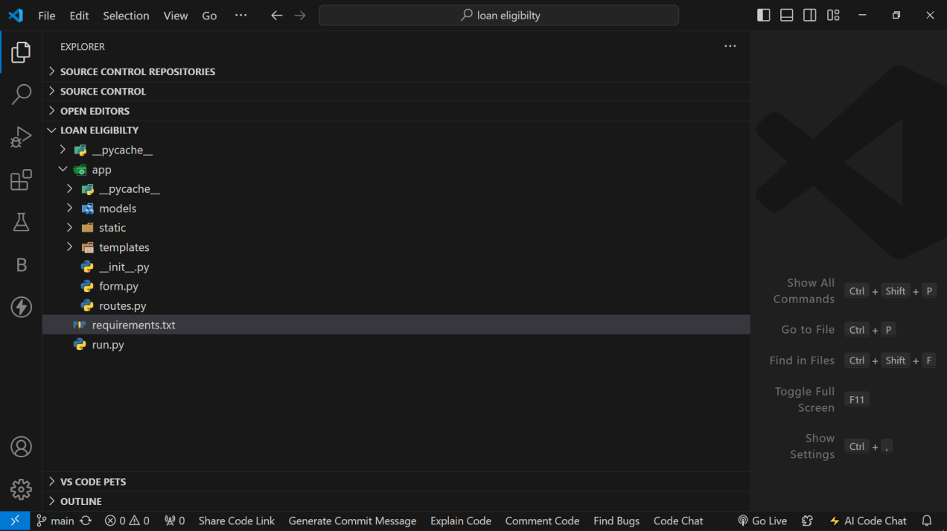

“App” is like a package which contains on models folder, static folder, templates folder, __init__.py, form.py, routes.py  
  
MODELS FOLDER:  
  
This contains all the saved model, examples are  
Random forest joblib.h5  
Random forest model.h5  
  
STATIC FOLDER:

This contains all the CSS styling for your HTML example:  
”loan.css”

Templates folder:

This is a folder specifically for Flask “Templates”, that contains all the html  
NOTE: it must always be “Templates”. because flask will understand that you saved your html code there.  
  
__init__.py:  
This “__init__.py” this is a special python file that is responsible for initializing the Flask App. And yes it must be __init__.py

from flask import Flask

from flask_wtf.csrf import CSRFProtect

app = Flask(__name__)

app.config['SECRET_KEY'] = 'ehtx7132'

csrf = CSRFProtect(app)

from app import routes

The first two lines you import the libraries  
flask and flask_wtf.csrf  
  
the meaning of CSRF is cross site request forgery. This is used in our forms to add security.  
  
app = Flask(__name__):

This line creates an instance of the Flask class, assigning it to the variable app. The __name__ argument tells the Flask application where it's located, which is necessary for Flask to find resources like templates and static files. This app instance will be the central object of your Flask application, used to configure, route, and run the app.

The rest are still for security   
  
from app import routes